Department of Statistics

The Wharton School

University of Pennsylvania

STAT 603 August 2006

Module 1
Introduction: Data and Variation

What is Statistics?

Statistics, the discipline, is the art and science of extracting useful information from data
Two parts:
1) Exploratory Data Analysis - discovery (found it!)
summarization/description/exploration

2) Confirmatory Data Analysis - skepticism (really?)
confirmation/inference/assessment

Data analyst as detective (detects but isn't fooled)

Statistics helps us make decisions in the presence of uncertainty, variation.
What are Data?

Basically, a collection of numbers, labels, or symbols and the context of those values

Often, a sequence of measurements on a process (a time series)
- the time it takes to get to school each morning
- the closing price of GM each week
- the sales volume at Amazon.com each month

Often, a subset of a larger group (a.k.a., a sample from a population)
- the ages of the students in this class
- the preferences of potential automobile purchasers visiting a showroom
- the GMAT scores of the students in the front row

Key Feature: Variation

A common feature: virtually all data exhibit variation. The values are not all the same. Even though each value for age is measured in years, the measurement is likely to be different for each person.

A principle goal of statistics is to describe and understand the implications of variation.
An Illustrative Example of a Statistical Analysis
All good analyses begin with a question, such as “How should I invest my money?” Once we have a question in mind, we can focus on finding relevant data.

Consider the choice between two stocks, say EBAY and OSIP. To make our choices more realistic, we’ll pretend we have to choose one of these two based on the data available in 2003. Our choice is to pick one of these going forward.

The data that we have measure the daily values of stock in these two companies in 2003. We will arrange this data into a table.

The rows in the table go by various names, such as observations, cases, or even subjects. The table collects measured values of various attributes of the observations.
The columns in the table are called “variables.” Each column holds the value of some attribute of the observations that define the rows of the table.

The JMP software organizes and presents the data in a table.
We begin by clicking on the JMP file “EBAY & OSIP 2003.JMP”, which contains daily prices and returns from 2003. The variables are listed at the left and repeated in the column headings.
The rows in this case denote the trading days during 2003. With time series, the rows always denote the time of the measurement.
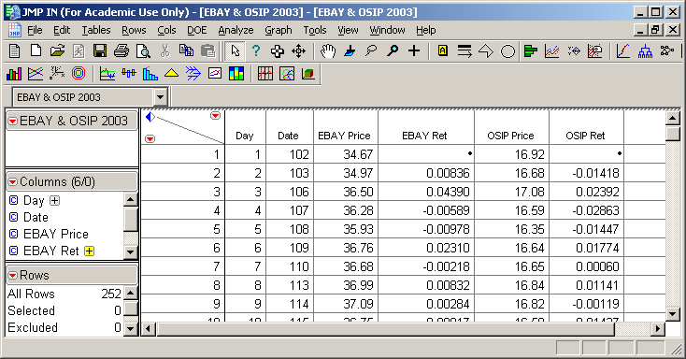
In the EBAY & OSIP 2003.JMP data, there are observations on variables.

JMP provides many useful interactive graphics. Let’s first use it to produce the following
time series plots of the daily prices.

When data form a time series, it’s best to look first for the effects of the passage of time by looking at a sequence plot.
Would this plot be more useful with a common axis for both series?

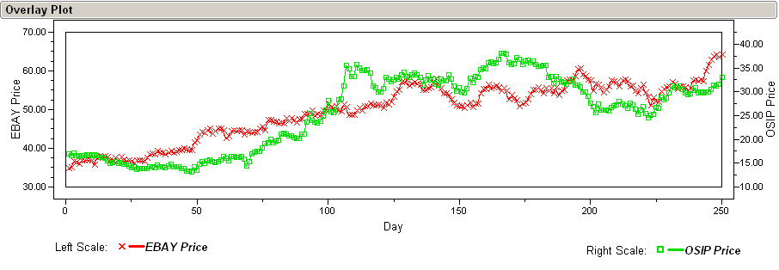

Which of these investments would have been better to hold throughout 2003?
A much more challenging question is, based on this data which of EBAY or OSIP would be better investment for the future?

To answer such a question, we look at the net returns rather than the prices.

As we will see later in the course, the returns are a much more stable process, and so are more useful for prediction. It is much simpler to describe and summarize the variation in the returns than the variation in the original series.

JMP is easily used to obtain graphical comparisons of the two sets of returns. To facilitate comparisons, the pair of histograms on the right use a common scale for both variables.

Histograms - Show bars that represent counts of returns in an interval.

Boxplots - Summarize the data further, drawing lines at certain ordered values.

Shape - What remains after you remove the value labeling on the axes.

How do the returns on the two assets compare?
In Finance, the variation in the returns measures the risk of owning an asset.
JMP is also easily used to obtain numerical summaries of the two sets of returns. These summaries can be used to quantify the differences seen in the previous histograms.

Mean –the average of the returns

St Dev – a measure of the variation of the returns

How do the returns on the two assets compare? What sort of trade-off has to be made?
We have seen that compared to EBAY, OSIP yielded a higher return on average but was also more volatile.

As we will see in Modules 5 and 6, such variation diminishes the long run value of an asset by an amount that we can quantify.

We will also see that a portfolio of partial investments in EBAY and OSIP would provide a better expected long run return than a 100% investment in either one.

But Don’t Worry

The main purpose of this example is to whet your appetite for what we will cover.

The methods and techniques illustrated here will all be carefully defined and motivated throughout the course.

We begin with graphical and numerical summary statistics in the next Module.

Any numerical summary of data, such as an average, is called a statistic.
EBAY operates an online market place. OSIP discovers, develops and markets anti-cancer products.
These data were downloaded from the CRSP database on WRDS, and then stored in the JMP file.
These data were downloaded from the CRSP database on WRDS, and then stored in the JMP file.

